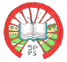 **MICKLEY VILLAGE PRIMARY & NURSERY SCHOOL**

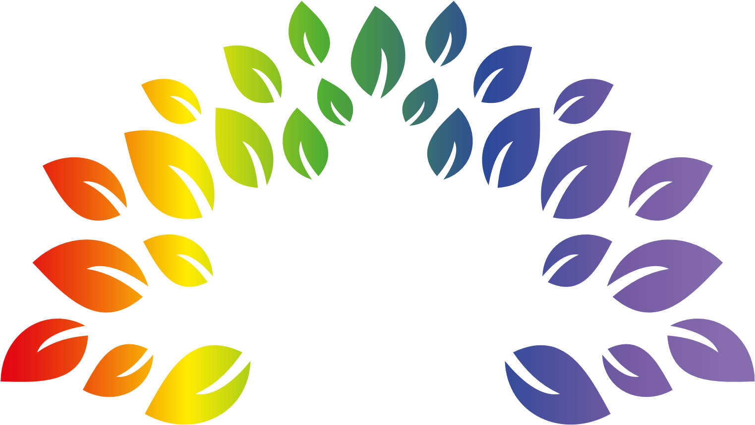

policy document

PSHCE

Personal, health and social education (PSHE) and citizenship enables children to become healthy, independent and responsible members of society. At Mickley Village Primary and Nursery School we encourage our pupils to play a positive role in contributing to the life of the school and the wider community. In doing so we help develop their sense of self- worth. We teach them about rights and responsibilities. They learn to appreciate what it means to be a positive member of a diverse multicultural society.

# Aims and objectives

The aims of personal, health and social education and citizenship are to enable the children to:

 know and understand what constitutes a healthy lifestyle;  be aware of safety issues;  understand what makes for good relationships with  others;  have respect for others; be independent and responsible members of the school community;  be positive and active members of a democratic society;  develop self-confidence and self-esteem, and make informed choices regarding personal and social issues;  develop good relationships with other members of the school and the wider community.

Learning and Teaching

We use a range of teaching and learning styles. We place an emphasis on active learning by including the children in discussions, investigations and problem-solving activities. We encourage the children to take part in a range of practical activities that promote active citizenship, e.g. charity fund-raising, the planning of school special events such as an assembly or open evening, or involvement in an activity to help other individuals or groups less fortunate than themselves. We organise classes in such a way that pupils are able to participate in discussion to resolve conflicts or set agreed classroom rules of behaviour. We offer children the opportunity to hear visiting speakers, such as health workers, police, and representatives from the local church, whom we invite into school to talk about their role in creating a positive and supportive local community.

The children are also given the opportunity to state their views through a school council. Representatives also discuss with the Head teacher outcomes from the discussions in an informal setting.

Curriculum planning

We teach PSHCE and citizenship in a variety of ways. In some instances, e.g. drugs education, we teach PSHE and citizenship as a discreet subject (See Drugs Awareness and Sex Education policies)

Some of the time we introduce PSHE and citizenship through other subjects. As there is a large overlap between the programme of study for religious education and the aims of PSHE and citizenship, we teach a considerable amount of the PSHE and citizenship through our religious education lessons, assemblies, lunch and breaktimes.

Foundation Stage

I n the Sunflower Unit we relate the PSHCE and citizenship aspects of the children's work to the objectives set out in Development Matters and Early Learning Goals (ELG's). Our teaching in PSHCE and citizenship matches the aim of developing a child's personal, emotional and social development as set out in the El-GIs. We also support citizenship education when we teach "how to develop a child's knowledge and understanding of the world". The children are also encouraged to have their own views and make these known to their teachers.

# Contribution to other subjects

PSHCE underpins all aspects of the education of the children at Mickley Village Primary and Nursery School (See curriculum policies, Sex Education policy and Drugs awareness policy). PSHCE forms part of our ethos as a Health Promoting School.

Resources

The resources for PSHCE and citizenship are kept in a central store.

# Health and Safety

The children are encouraged to be considerate and aware of their own health and safety and towards that of others during activities.

Assessment and Recording

Teachers assess the children's work in PSHCE and Citizenship by making informal judgments as they observe them during lessons. We have clear expectations of what the pupils will know, understand and be able to do at the end of each key stage and use a variety of materials including SEAL to contribute to these judgments. The involvement of children in their own assessment is an essential educational aim (see assessment policy). Children are involved in the evaluation of their work through agreeing next steps with their teacher. They are encouraged to comment on their work themselves before handing it in or discussing it with the teacher and through self-evaluation (what would they like to do better next time?) (see marking and feedback policy) Parents are involved in assessment and recording through regular informal discussions, more formal parental consultation evenings and through annual reports. Parents have the opportunity to discuss progress at any time through the school's open door policy.

Equal opportunities

PSHCE forms part of the Mickley Village Primary and Nursery School's curriculum policy to provide a broad and balanced education to all children (see Race Equality Statement, Equal opportunities policy and Inclusion policy/statement). We provide learning opportunities matched to the needs and abilities of the children and take into account the targets set for individual children in their individual education plans (IEP'S) The learning of more-able children is extended as appropriate to their age and ability through extension activities and questioning.

Review of policy

The policy will be reviewed by the co-ordinator on a regular basis and appropriate amendments made.