DISABILITY EQUALITY SCHEME

School Name: Mickley Village Primary and Nursery School

3-year period covered by the scheme: December 2022- December 2025

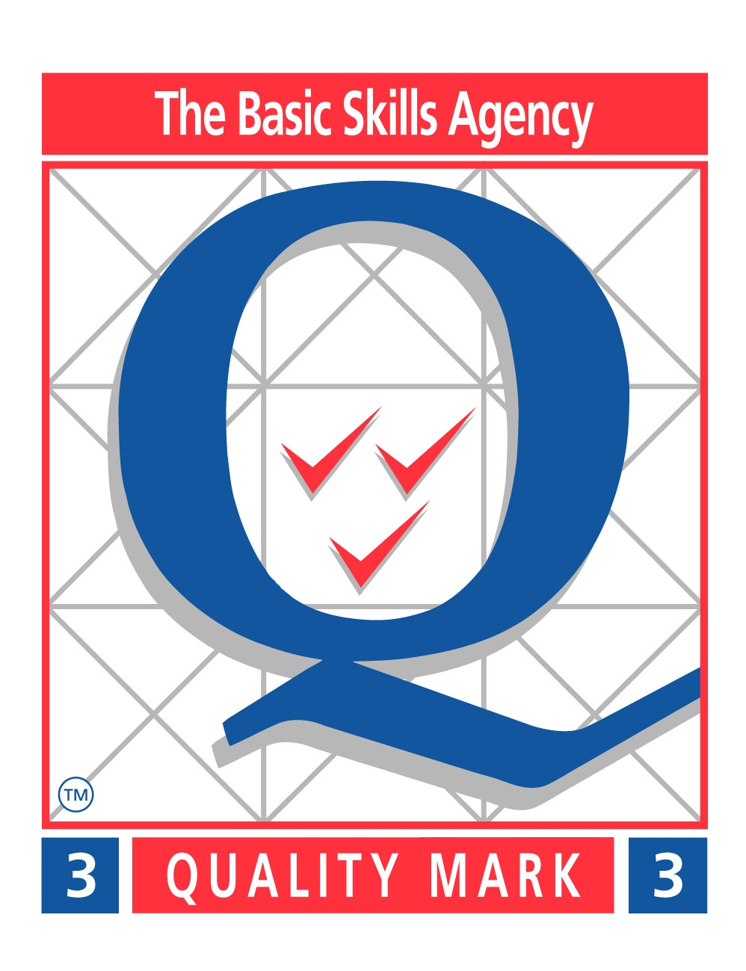

Introduction

Duties under Part 5A of the DDA require the governing body to:
- promote equality of opportunity for disabled people: pupils, staff, parents, carers and other people who use the school or may wish to; and
- prepare and publish a disability equality scheme to show how they will meet these duties.

This scheme and the accompanying action plans set out how the governing body will promote equality of opportunity for disabled people.

Duties in Part 4 of the DDA require the governing body to plan to increase access to education for disabled pupils in 3 ways:
- increasing the extent to which disabled pupils can participate in the school curriculum;
- improving the environment of the school to increase the extent to which disabled pupils can take advantage of education and associated services;
- improving the delivery to disabled pupils of information which is provided in writing for pupils who are not disabled.

This scheme incorporates the school’s plans to increase access to education for disabled pupils.

1: Starting points

1.1: The purpose and direction of the school’s scheme

The General Duty
- promote equality of opportunity between disabled people and other people;
- eliminate discrimination that is unlawful under the Disability Discrimination Act;
- eliminate harassment of disabled people that is related to their disability;
- promote positive attitudes towards disabled people;
- encourage participation by disabled people in public life;
- take steps to meet disabled people’s needs, even if this requires more favourable treatment.

Accessibility Plan Vision / Values

Mickley Village Primary and Nursery School is a fully inclusive school. There is equality of opportunity for all pupils to follow a full National Curriculum timetable and to take part in extra curricular activities and be involved fully in the life of the school. We aim to meet the needs of all pupils at the school effectively to ensure that they benefit as fully as possible from the education and experiences they receive and are able to attain their full potential.

1.2: Involvement of disabled pupils, staff and parents

Involving disabled people is a requirement of a scheme and brings real benefits in terms of;
- Providing insights into the barriers faced by disabled pupils, staff and parents
- Developing expertise in identifying ways to overcome these barriers
- Improving working relationships between schools and disabled pupils, staff and parents.
- Information is gathered from staff via meetings and consultation on documentation.
- Information is gathered from pupils via the annual questionnaire and School Council.
- Information is gathered from parents through consultation letters, questionnaires,parents meetings and informal meetings through the schools open door policy.

1.3: Information gathering

Mickley Village Primary and Nursery School defines Disability in line with the current definitions in the Disability Discriminations Act (DDA). This means that is this school we define Disability as:

‘a physical or mental impairment which has a substantial and long-term adverse effect on his or her ability to carry out normal day-to-day activities.’

Definition of the terms:
- ‘physical impairment’ includes sensory impairments;
- ‘mental impairment’ includes learning difficulties and an impairment resulting from or consisting of a mental illness;
- ‘substantial’ means ‘more than minor or trivial’; and
- ‘long-term’ is defined as 12 months or more.

The definition includes a wide range of impairments, including hidden impairments such as dyslexia, autism, speech and language impairments, Attention Deficit Hyperactivity Disorder (ADHD). These are all likely to amount to a disability, but only if the effect on the person’s ability to carry out normal day-to-day activities is substantial and long-term, as defined above.

The effect on normal day-to-day activities is on one or more of the following:
- mobility;
- manual dexterity;
- physical co-ordination;
- continence;
- ability to lift, carry or otherwise move everyday objects;
- speech, hearing or eyesight;
- memory or ability to concentrate, learn or understand;
- perception of risk of physical danger.

Some people are automatically covered by the definition: those with cancer, multiple sclerosis, HIV infection or a severe disfigurement. There are special provisions for people with progressive or recurring conditions.

In our school the following adjustments are made to support school users who have a disability:

a) Speech and language therapy for children who have additional needs
b) Precision teaching (1 to 1) for children who lack ability to concentrate, learn or understand.
c) Disabled toilet access is available.
d) Ramps are available as part of the school design for wheelchair users to enable accessibility throughout the school.
e) Allocated disabled parking is available.
h) Hearing impaired teacher access
i) Physiotherapy services – external
j) Intervention groups for specific needs

Our current disabled population is:

Disability | %
Mobility | 0
Manual dexterity | 0
Physical co-ordination | 2
Continence | 2
Ability to lift, carry or otherwise move everyday objects | 0
Memory or ability to concentrate, learn or understand | 14
Perception of risk of physical danger | 4

Information Gathering Process for all schools users.

We have gathered information from a number of sources.
- We have surveyed all current pupils, parents, carers and users of the school to gain their views on current provision and future aspirations.
- We have contacted local disabled people’s groups and asked for their views.
- We have discussed the issues with all feeder schools’/ nursery providers in the area.
- We have jointly discussed access with other local schools and produced details of other local provision.

The information is needed to allow the school to plan for the future so that the needs of the local disabled community as school users can be anticipated under the planning duty and met for all users. The information is used in such a way that individuals will be unidentifiable and therefore confidentiality is maintained.
In our school we look on the issue of someone not being able to access something because of a disability as being a problem with what is provided, not the person using the facility or accessing the provision, we would encourage people to make their needs known to us so that we can ensure that they do have full access.
We recognise that this is our first Disability Equality Scheme and that we need, as one of the priorities for the action plan to look at how we can keep this information up to date and involve members of the disabled community in the ongoing life of the plan. This will improve the quality of the information available when the plan is reviewed in three years time.

- We have also gathered information about recruitment, development and retention of disabled employees.

We have reflected on the respective responsibilities of the school and the local authority and we have ensured that we are able to collect information on new staff through the recruitment process by the disability and equal opportunities questionnaire which forms part of the application form process. This information will be collected through the life of the Disability Equality Scheme and will inform the priorities for the next scheme.

We have discussed the need to have information on disability with current staff and have collected this information by staff meeting and consultation on the Accessibility plan with all staff.

The information collected shows how disabled staff are represented amongst different groups of employees, at different levels of the school, and amongst those who leave the school.

Academic Year 2022 / 23

Mobility
 | % In post | % Leavers
Management | 0 | 0
AST | 0 | 0
UPS | 0 | 0
Main Scale | 0 | 0
Teaching Assistant | 0 | 0
Clerical | 0 | 0
Other | 0 | 0

Manual Dexterity

 | % In post | % Leavers
Management | 0 | 0
AST | 0 | 0
UPS | 0 | 0
Main Scale | 0 | 0
Teaching Assistant | 0 | 0
Clerical | 0 | 0
Other | 0 | 0

Physical Co-ordination

 | % In post | % Leavers
Management | 0 | 0
AST | 0 | 0
UPS | 0 | 0
Main Scale | 0 | 0
Teaching Assistant | 0 | 0
Clerical | 0 | 0
Other | 0 | 0

Continence

 | % In post | % Leavers
Management | 0 | 0
AST | 0 | 0
UPS | 0 | 0
Main Scale | 0 | 0
Teaching Assistant | 0 | 0
Clerical | 0 | 0
Other | 0 | 0

Ability to lift, carry or otherwise move everyday objects

 | % In post | % Leavers
Management | 0 | 0
AST | 0 | 0
UPS | 0 | 0
Main Scale | 0 | 0
Teaching Assistant | 0 | 0
Clerical | 0 | 0
Other | 0 | 0

Speech, hearing or eyesight

 | % In post | % Leavers
Management | 100
AST
UPS
Main Scale
Teaching Assistant | 33%
Clerical
Other

Memory or ability to concentrate, learn or understand
 | % In post | % Leavers
Management | 0 | 0
AST | 0 | 0
UPS | 0 | 0
Main Scale | 0 | 0
Teaching Assistant | 0 | 0
Clerical | 0 | 0
Other | 0 | 0

Perception of risk or physical danger
 | % In post | % Leavers
Management | 0 | 0
AST | 0 | 0
UPS | 0 | 0
Main Scale | 0 | 0
Teaching Assistant | 0 | 0
Clerical | 0 | 0
Other | 0 | 0

Mickley Village Primary and Nursery School recognises the following benefits of a diverse workforce in our community.

a) Accessibility for all
b) Equality of opportunity

Educational opportunities available to and the achievements of disabled pupils.

Information about disabled pupils which is already available to the school comes from initial data collection through admissions forms and further parental consultations throughout the child’s time at the school.

Using the understanding of which pupils may count as disabled which we have established earlier in the scheme we have analysed this data against:
- the presence;
- participation; and
- achievements of disabled pupils.

Presence:

Our current disabled population is:
Disability | %
Mobility | 0
Manual dexterity | 0
Physical co-ordination | 2
Continence | 2
Ability to lift, carry or otherwise move everyday objects | 0
Memory or ability to concentrate, learn or understand | 14
Perception of risk of physical danger | 4

The table above shows our analysis of the Disabled population in our school.
It shows:
- what % disabled pupils there are in the school;
- which impairment groups are represented in the school; and
- whether there are groups of disabled pupils who are not represented at the school.

This tells us that the majority of our disabled pupils have concentration difficulties.

Participation

From the analysis of the information we have collected about the participation of disabled pupils we have decided on the following priorities for the Disability Equality Scheme.

Priority 1 Assessment and evaluation of all pupils progress on a regular basis to ensure potential is reached (see Accessibility Plan)

Priority 2…Reasonable adjustments will be made to ensure that all pupils can access extra curricular activities and educational visits

From this analysis we have also decided that the following issues can be addressed by making reasonable adjustments.

Issue 1 Supporting children who do not make expected progress identified through analysis of progress and test results.

Reasonable Adjustment providing extra support and precision teaching for pupils when need arises. Consulting external agencies for advice. Making adjustments to curriculum to enable access.

Issue 2

Reasonable Adjustment changing travel facilities to ensure disabled access. Ensuring support for child is available to access extra curricular opportunities and clubs.

We have analysed the achievements of our disabled pupils against the same success criteria we use for all our pupils including:

- end of key stage outcomes
- achievements in extra-curricular activities
- broader outcomes
- Discussion at School Council level with older pupils.

From this analysis we have seen that all pupils all our pupils access appropriate support as identified by their disability. All pupils access extra-curricular activities regardless of dis/ability.
Our priority to address this is to continue our analysis of data and consultation of pupils through the School Council, questionnaires for pupils and parents and parents meetings.

Information on disabled parents, carers and others using the school.

We make reasonable adjustments for any parent, carer or member of the community using our schools e.g. allowing disabled toilet access, parking facilities and ramps.

1.4: Impact assessment

Impact assessment is a systematic approach to the analysis of the effects of a policy, practice or procedure for disabled pupils, staff and parents.

The main mechanism by which our school will assess the impact of their current policies will be by bringing together:
- the issues identified through the involvement of disabled pupils, staff and parents; and
- the information that the school holds on the disabled pupils, staff and parents.

Over the lifetime of the scheme we will assess the impact of on disabled people of our current policies. We will involve disabled people in prioritising what is to be looked at first. Impact assessment will be incorporated into the school’s planned review and revision of existing policies and into the process of developing new policies.

2: Identifying the main priorities for your school’s scheme and deciding your actions.

The priorities for the school’s scheme have been set in the light of:
- an examination of the information that the school has gathered; and
- the messages that the school has heard from the disabled pupils, staff and parents who have been involved in the development of the scheme.

Priorities identified are about:
- improving information;
- Improving the involvement of disabled pupils, staff and parents.

The actions we will take to promote equality of opportunity will address the six elements of the general duty:

We are working proactively to make reasonable adjustments for disabled pupils at policy and whole school level, as well as for individual pupils, through this we promote equality of opportunity for disabled pupils and to secure their participation in every aspect of school life.
We have incorporated priorities from our accessibility plan into the scheme.

These are:
Priority 1
Assessment and evaluation of all pupils progress on a regular basis to ensure potential is reached (see Accessibility Plan)

Priority 2
Reasonable adjustments will be made to ensure that all pupils can access extra curricular activities and educational visits

Priority 3
To work with Derbyshire County Council to ensure that the new build has disabled access, toilets and disability friendly resources.

Disabled parents, carers and others who use the school by providing access to disabled toilet facilities and ramps around school for wheelchair access.

We are working proactively to eliminate discrimination,
for example:
- by awareness raising and staff training;
- by keeping a watchful eye on the impact of policies;
- reviewing and adjusting policies;
- raising expectations;
- improving communication.

This will be achieved through staff meetings, School Improvement Planning and consultations with staff, pupils and parents.

We are working proactively to eliminate harassment.
We will;
- raise awareness amongst staff and pupils of disability-related harassment;
- understand the nature and prevalence of bullying and harassment;
- recognise and address bullying and harassment;
- involve pupils themselves in combating bullying;
- ensure that disability-related harassment of disabled staff, parents, carers and other users of the school is identified and addressed.

This will be done through our anti-bullying commitment, School Council, staff meetings and consultation.

We are working proactively to promote positive attitudes to disability, for example:
- by staff modelling respectful attitudes to disabled pupils, staff and parents;
- by ensuring representation of disabled people in senior positions in the school;
- through positive images in school books and other materials.

Disabled pupils, staff and parents are encouraged to participate in school life:

they see their disabled peers included and succeeding in the life of the school;

disabled pupils, staff and parents are represented in senior, responsible and representative roles;

there are positive images of disabled people participating.

All pupils and staff are included in all activities, with reasonable adjustment made where necessary.

We will ensure that the policies of the school and the climate of the school is designed to meet disabled pupils needs. We will give due consideration to the fact that in order to do this we may have to ensure that the disabled person receives more favourable treatment.

3: Making it happen

3.1: Implementation

In order to ensure the that the scheme is effectively implemented we will ensure that:
- the scheme is supported by a detailed action plan; and
- the action plan is incorporated into a framework that has the oversight of the governing body, and that progress is checked.

The action plan will show:
- clear allocation of lead responsibility;
- clear allocation of resources;
- an indication of expected outcomes or performance criteria;
- clear timescales;
- a specified date and process for review.

The scheme will be linked to both the full School Improvement Plan and the Accessibility Plan to ensure that the scheme is reviewed on a regular basis by the governing body.

Evaluation

We will evaluate the effectiveness of this scheme and reflect this evaluation in our discussions with:
- their school improvement partner; and
- Ofsted, when the school is inspected.

3.2: Publication

The school’s scheme will be published:

as a separate document and as part of other school documents, for example an equal opportunities policy or the school improvement plan.

And is available from The School Office

This scheme was published on 23rd January 2017 and will be in operation until February 2020

3.3: Reporting

We will report annually on:
- the progress we have made on our action plan; and
- the effect of what we have done.

The report on the scheme will be in a separate document

3.4: Reviewing and revising the scheme

As part of the review of the scheme, we will:

- revisit the information that was used to identify the priorities for the scheme; and
- re-examine the information to see if actions that the school has taken have affected opportunities and outcomes for disabled pupils, staff and parents.

The review of the scheme will inform its revision: how the school sets new priorities and new action plans for the next scheme. This process will again:
- involve disabled pupils, staff and parents; and
- be based on information that the school has gathered.

Over time we will align our accessibility plan and our disability equality scheme so that we produce a new scheme and plan at the same time.
This ACTION PLAN picks up the Priorities Highlighted in Sections 1 and two of the DES and the Accessibility plan.

DES SECT | TARGET | ACTION | LEAD  RESP. | PERFORMANCE  INDICATORS/MILESTONES | QUALITY  ASSURANCE  PROCESSES
Priority 1 | Assessment and evaluation of all pupils progress on a regular basis to ensure potential is being reached | Tracking by HT on school grids and reporting to Governing Body on progress.  Regular assessment by teachers | H.T /  Gov | Children will be tracked and highlighted as to areas of need.  Children will be targeted to address areas of need.  Intervention programmes will be used as necessary. | Areas of concern discussed with Gov Body.  SSSEN support used as appropriate to needs of individuals.
Priority 2 | Reasonable adjustments will be made to ensure that all pupils can access extra curricular activities and educational visits | Coaches with disabled access will be made available when necessary for disabled pupils.  Extra support will be provided to enable disabled pupils to access extra curricular activities.  Reasonable adjustments will be made in any other area where need arises. | HT / Gov Body | All children will be able to access visits or extra curricular activities should they wish to do so. | Take up of visits and activities will be high (80-100%)
Priority 3 | The new school building will have disabled access, toilet facilities and be accessible to all | As recommended by DCC | HT / Gov Body / Jenny Webster | The new building planning will ensure accessibility and disability friendly resources | Checks by Gov Body / HT as to progress.  .

