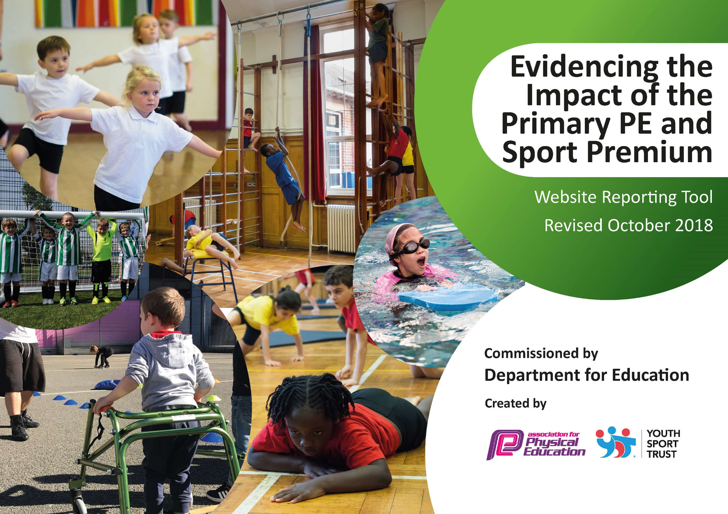
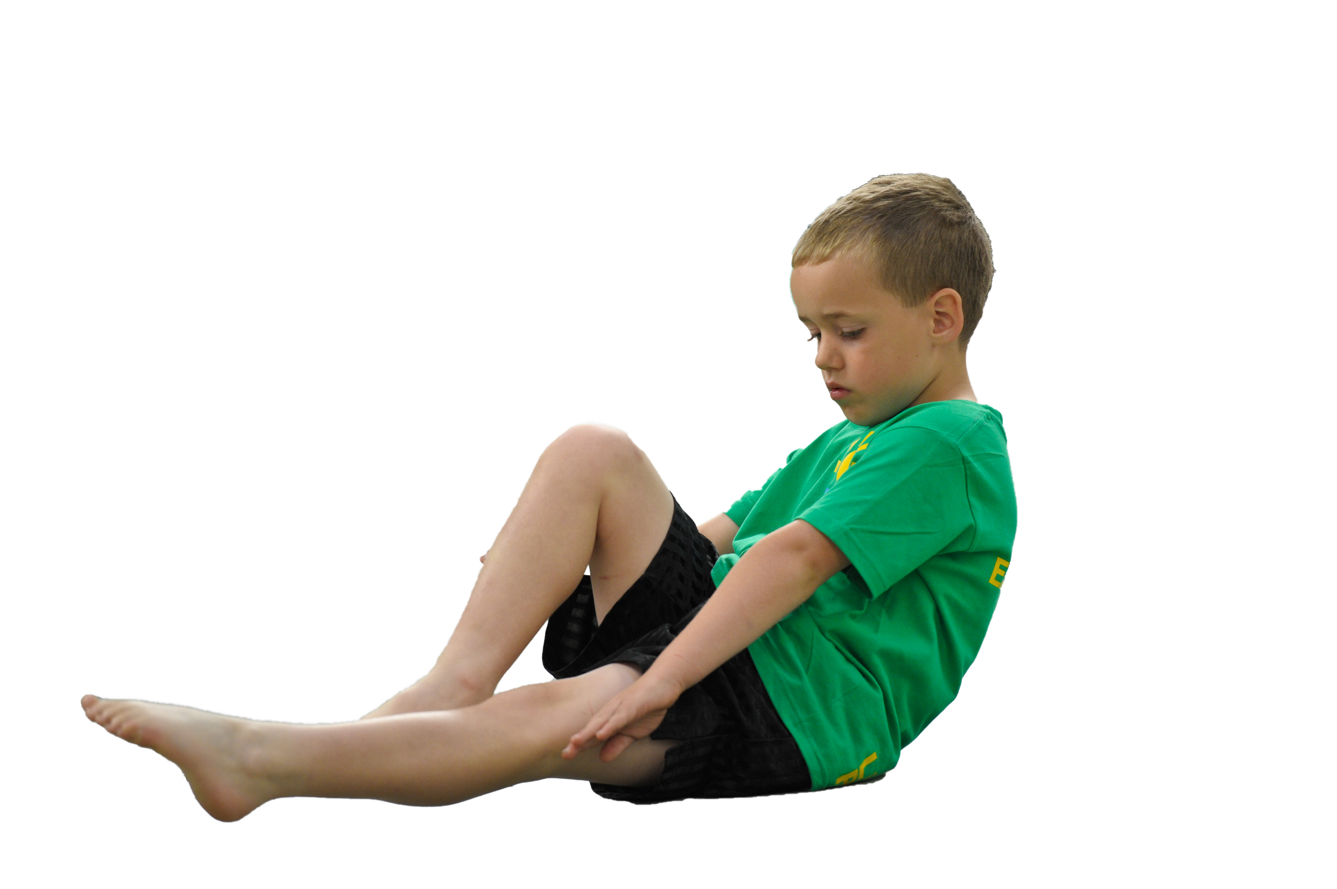
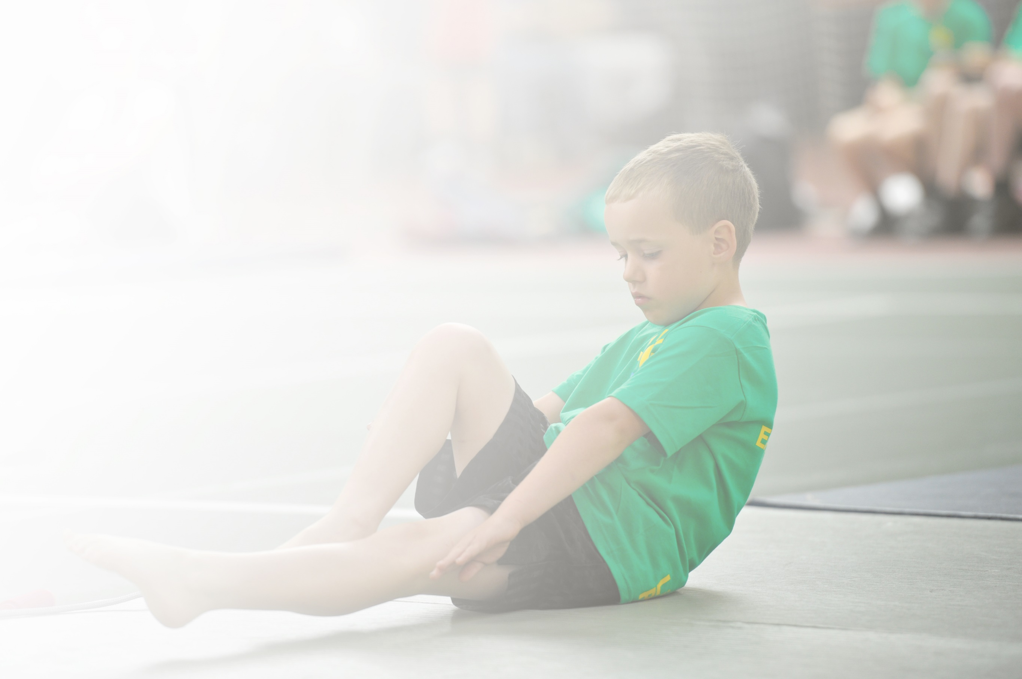
Schools must use the funding to make additional and sustainable improvements to the quality of Physical Education, Sport and Physical Activity (PESPA) they offer. This means that you should use the Primary PE and Sport Premium to:

- Develop or add to the PESPA activities that your school already offer
- Build capacity and capability within the school to ensure that improvements made now will benefit pupils joining the school in future years

Please visit gov.uk for the revised DfE guidance including the 5 key indicators across which schools should demonstrate an improvement. This document will help you to review your provision and to report
your spend. DfE encourages schools to use this template as an effective way of meeting the reporting requirements of the Primary PE and Sport Premium.

We recommend you start by reflecting on the impact of current provision and reviewing the previous
spend. Under the Ofsted Schools Inspection Framework, inspectors will assess how effectively leaders use the Primary PE and Sport Premium and measure its impact on outcomes for pupils, and how effectively governors hold them to account for this.

Schools are required to publish details of how they spend this funding as well as on the impact it has on pupils’ PE and sport participation and attainment by the end of the summer term or by 31 July 2020 at the
latest.
We recommend regularly updating the table and publishing it
on your website throughout the year, as evidence of your
ongoing review into how you are using the money to
secure maximum, sustainable impact. To see an
example of how to complete the table please
click HERE.

Support for review and reflection - considering the 5 key indicators from DfE, what development needs are a priority for your setting and your students now and why? Use the space below to reflect on previous spend, identify current need and priorities for the future.

Key achievements to date: | Areas for further improvement and baseline evidence of need:
The MUGA has been used more widely this academic year with AVSSP sports coach using this for some activities.  After school club offer has been enhanced through a greater variety of sports on offer through AVSSP.  Some students have taken part in sports activities with another local small school supported by AVSSP.  We received a fully funded sports pack full of equipment for sports/games through the Aldi sports for schools initiative which will be used in sports activities by both staff and sports coaches.  Our reception and Y2 children took part in bikeability sessions from Big on bikes. | Develop curriculum use of MUGA.  Purchase of new equipment suitable for use in MUGA.  To take part in more inter-school activities.

Action Plan and Budget Tracking
Capture your intended annual spend against the 5 key indicators. Clarify the success criteria and evidence of impact that you intend to measure to evaluate for students today and for the future.

Academic Year: 2019/20 | Total fund allocated: £9036 | Date Updated: July 2020
Key indicator 1: The engagement of all pupils in regular physical activity – Chief Medical Officer guidelines recommend that primary school children undertake at least 30 minutes of physical activity a day in school |  |  |  | Percentage of total allocation:
 |  |  |  | 3.98%
School focus with clarity on intended impact on pupils: | Actions to achieve: | Funding allocated: | Evidence and impact: | Sustainability and suggested next steps:
All pupils participate in golden mile  on a daily basis | Time out during school day | £0 – no additional equipment required. | All children to take part in daily physical activity as per guidelines. | Become a regular feature of the school timetable.
Have activity equipment available to pupils at lunch time. Purchase both physical activity and sporting equipment. | Bikes, footballs and other sports equipment are available each break and lunch time with children also able to use the muga facilities during this time. Children also have use of the trim trail at break and lunch times.  Maintenece of the trim trail to make it safe and enable children to continue to use. | £0 – equipment is existing.  Repair of trim trail £360 | - Pupils to have a better experience of Physical activity and School Sport at lunch times  - Lunch time staff to feel more comfortable delivering activity  - Lunch times will have more variety of activity  - Equipment will be able to be used at other times in the day | - Look to expand our range of sports equipment  - Develop lunch time staff through training on how to use the equipment
Key indicator 2: The profile of PESSPA being raised across the school as a tool for whole school improvement |  |  |  | Percentage of total allocation:
 |  |  |  | 57.66%
School focus with clarity on intended impact on pupils: | Actions to achieve: | Funding allocated: | Evidence and impact: | Sustainability and suggested next steps:
Sports coach to attend school one afternoon per week and lead after school club. | · AVSSP sports coaches to run sport and physical activity during lunch time – once a week  . AVSSP sports coach to provide a PE session – one afternoon per week  .AVSSP sports coach to run a sports after school club – one day per week | AVSSP – 6 half terms - £4560  AVSSP affiliation £650 | · Improve physical activity of pupils at lunchtimes.  · Pupils motivated and inspired to be active for more of the day  · Improved fitness with children more active in lessons  · Contributes to improved attainment  . Enable children to take part in a varied range of sports that they might not otherwise get to take part in | · Sports Coach to pass on game ideas to regular staff for them to continue games on other days and into future years.  · More children taking part in physical activity and able to lead each other in sports and games

Key indicator 3: Increased confidence, knowledge and skills of all staff in teaching PE and sport |  |  |  | Percentage of total allocation:
 |  |  |  | 33.2%
School focus with clarity on intended  impact on pupils: | Actions to achieve: | Funding  allocated: | Evidence and impact: | Sustainability and suggested  next steps:
Yoga and mindfulness | Yogabugs sessions watched by staff for coaching purposes. | Yogabugs - £3000 | Staff use some of the activities in their own practise. Yoga session demo to parents well attended. | Continue as both staff and children are benefitting.
Sports coach | Staff to gain guidance and advice from AVSSP sports coach to enable them to provide high quality sports and activities | Included in AVSSP cost. | Staff more confident in preparing and conducting PE activities. | Staff to observe sports coach.
Key indicator 4: Broader experience of a range of sports and activities offered to all pupils |  |  |  | Percentage of total allocation:
 |  |  |  | 4.39%
School focus with clarity on intended  impact on pupils: | Actions to achieve: | Funding  allocated: | Evidence and impact: | Sustainability and suggested  next steps:
Additional activities/achievements  Bikeability – Big on bikes  African dance session  Junior leadership conference - AVSSP | Reception & Y2 gained experience & confidence whilst learning to ride a bike safely.  Provided by African Ark – link cultural activities and dance from other cultures  Y2 children attended a mini sports leader session with AVSSP | Y2 funded by AVSSP  Reception £126  African Ark cost £155.74  Part funded by AVSSP £15  Transport to venue - £100 | . Children received a certificate and feedback to take home  . Pupils inspired and motivated to take part  . Children gained confidence and leadership skills in sport which they can also apply to other aspects of their development | Continue to affiliate to AVSSP  Continue to take part in additional sessions to broaden the range of sports activity available.
Increase the participation in after- school sports clubs with an increased number of clubs, places and a broader range of activities. | - Timetable the extra-curricular clubs in multi-sports and dance.  - Communicate clubs to pupils and parents.  - Enrol pupils. | Included in AVSSP cost. | - Increased number of pupils taking part in extra-curricular clubs.  - Pupils motivated to take part in more activity more often.  - Pupils develop leadership, teamwork and communication skills.  - Wider impact of increased self- esteem/confidence, contributing to learning and attainment. | - More children taking part in physical activity and games.  - Pupils develop higher expectations for their personal fitness.
Key indicator 5: Increased participation in competitive sport |  |  |  | Percentage of total allocation:
 |  |  |  | 0%
School focus with clarity on intended  impact on pupils: | Actions to achieve: | Funding  allocated: | Evidence and impact: | Sustainability and suggested  next steps:
Pupils took part in a football/dodgeball competition at our school with another small school from our local area organised by AVSSP. | Participate in competitive sport with pupils from another school | Included in AVSSP cost | Participation celebrated at assembly  Pupils inspired and motivated to take part (feedback) | - Continue to affiliate to AVSSP  - Identify staff members with specific skills/interests to run new sports sessions.

