At Mickley Village Primary and Nursery School we have shared and reflected upon what British values mean to us. Tolerance and respect are also our school values which are reinforced regularly and in age appropriate ways. We want our school community to be proud of their nation and understand how they can contribute as effective citizens. We understand that this important process begins at a very early age and we seek to nurture this at Mickley Village Primary and Nursery School.


Democracy
Children have many opportunities for their voices to be heard. We understand the need for their opinions and views to be at the centre of our decision making.
Staff model the democratic process on a daily basis by inviting questions and sharing views through discussion. Our children are taught explicitly to verbalise their thinking, to consider the greater good and be aware of the needs of others.
Children have a school council with whom they are able to put forward their views about the school.

The Rule of Law
The importance of laws, whether they be those that govern the class, the school, or the country, are consistently reinforced throughout our daily practice, as well as when dealing with behaviour and through whole school issues. Pupils are taught the value and reasons behind laws, that they govern and protect us, the responsibilities that this involves and the consequences when laws are broken. Visits from authorities such as Police, Road safety and Fire Service help reinforce this message.

Individual Liberty
Within school, pupils are actively encouraged to make choices, knowing that they are in a safe and supportive environment. As a school we educate and provide boundaries for young pupils to make choices safely, through provision of a safe environment and empowering education. Pupils are encouraged to know, understand and exercise their rights and personal freedoms and advised how to exercise these safely, for example through our E-Safety and PSHE lessons. Whether it be through choice of learning challenge, of how they record, of participation in our extracurricular opportunities, pupils are given the freedom to make choices. Lunchtime is a good example of this, every child works collaboratively, sharing equipment and engaging in good manners. As a school we do not shy away from routines that may be challenging instead we enable and train our children to make informed personal choices.

Mutual Respect
Respect is one of our school values. Children learn that their behaviour has an effect on their own rights and those of others. All members of the school community treat each other with respect. We also share the consequences of what happens when respect and tolerance are not employed as strategies. We regularly discuss current affairs with the children enabling them to make sense of the world they are in.
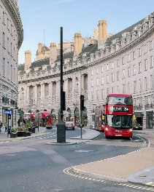
.

Tolerance of those of Different Faiths and Beliefs
Mickley is an area which does not have a great deal of cultural diversity, therefore we place a great emphasis on promoting diversity with the children. Assemblies are regularly planned to address this issue either directly or through the inclusion of stories and celebrations from a variety of faiths and cultures. Our RE, PSHCE and flexible curriculum teaching reinforce this. Members of different faiths or religions are encouraged to share their knowledge to enhance learning

What do we do at Micklev Infants to celebrate beinq British?

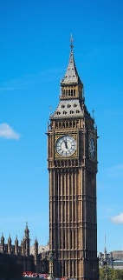
- Learn the National Anthem study key historical figures and events in British history learn the key geographical facts and regions of Britain
- Dance and listen to music from around Britain
- Study local birds and wildlife especially RSPB big bird watch
- Support national events such as the Olympics, World Cup etc.
- Participate in Forest School activities
- Enjoy the great outdoors and our local environment
- Visit local areas and experiences further afield .
- Share activities with local schools
- Celebrate Royal occasions

